Activity 1 - Difficulty Rate: Low / Medium
Target is to look at the forces of Gravity – motions of planets using Newton’s law (although these are not as precise as Einstein’s theory it is good enough for game development)

Open the Newton’s Lab 1.

- Compile All → right click on Space at the top of the world and choose sunAndTwoPlanets().

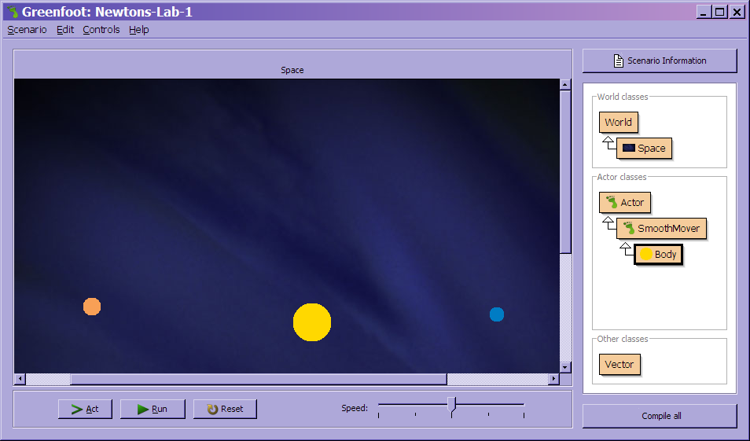

- Click run → nothing happens
- right click on Space at the top of the world and choose sunPlanetMoon() right click on the planets on the world and see what methods already exits

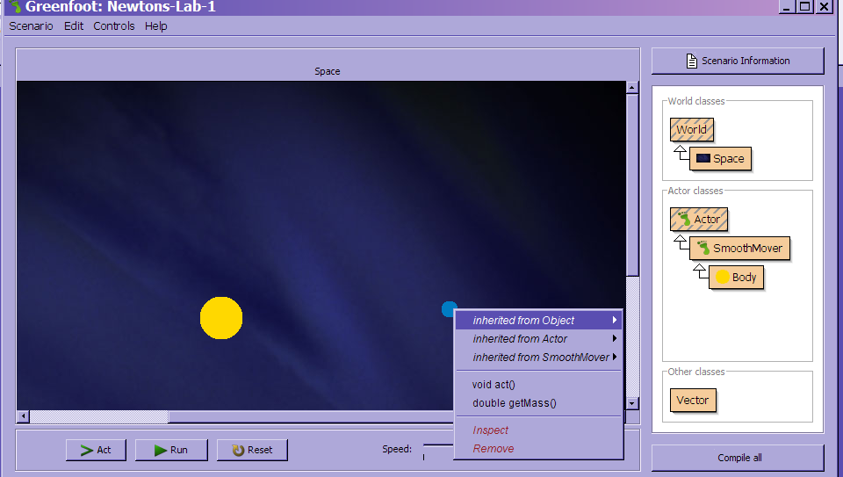
Look at the
double getMass() → this gives you a value

- There are other classes that are known as HELPERS -- SmootherMover and Vector

These help give more functionality and can be used in any scenario

SmoothMover – makes the actor movement smooth – it reads the co-ordinates as a double e.g. 14.7 --- and moves in 0.6 each move

But as pixels are a whole number (integer) the number has to then get rounded

The sub class of SmoothMover holds a vector – this indicates a current direction and speed of movement.

VECTOR -- can also be known as an invisible arrow → giving direction and length

- Right click the SmoothMover -- NOTE abstract

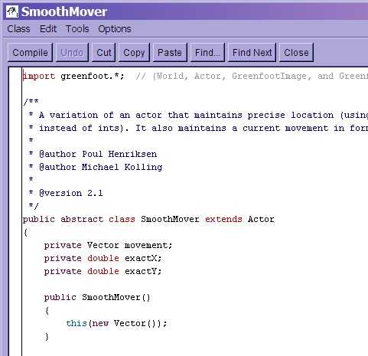
Abstract classes work as a super class for other classes they are not for creating an instance of

Task 1:

Look at the SmoothMover class and see what method names appear twice – how do the versions differ?

This is known as overloading (polymorphism) – more than one method with the same name

- Open the BODY class editor window – there are two constructor methods with the same name

This is the default constructor

public Body()
{
this (20, 300, new Vector(0, 1.0), defaultColor);
}

/**
* Construct a Body with a specified size, mass, movement and color.
*/
This constructor receives four parameters

public Body(int size, double mass, Vector movement, Color color)
{
this.mass = mass;
addForce(movement);
GreenfootImage image = new GreenfootImage (size, size);
image.setColor (color);
image.fillOval (0, 0, size-1, size-1);
setImage (image);
}

The following variables are constrant they are variables that do not change throughout the programme

public class Body extends SmoothMover
{
// constants
private static final double GRAVITY = 5.8;
private static final Color defaultColor = new Color(255, 216, 0);

- Creating movement

Open the BODY class → in the ACT ( ) method add move( ); → compile →

Add several planets SHIFT + CLICK

Task 2:

Right click space at the top of the scenario → choose sunAndPlanet( ) → run the scenario see what movement happens.

Task 3:

Change the default direction of a body to the left -- make the direction in the vector class negative

7. Importing LIBRARIES --- looking a the BODY class

import java.awt.Color; is the standard java LIBRARY imported this allows new colors to be set (NOTE: COLOR is spelt American not COLOUR)

new Color(255, 216, 0); this creates a new color

Activity 2 - Difficulty Rate: Medium - Adding Gravity

- Within the BODY class → After the close of the ACT( ) method → create a method applyForces( ) – this is a private method

/** Apply forces of gravity from all other celestial bodies
* in this universe
*/

private void applyForces()
{
//code will go in here soon
}

- inside the ACT( ) method → call the new applyForces( ) method

This applies gravity from other bodies in space

Add to ACT( ) → applyForces( );

/**
* Act. That is: apply the gravitation forces from
* all other bodies around, and then move.
*/
public void act()
{
applyForces();
move();
}

- within the Greenfoot World class the documentation gives us this method:

java.util.List getObjects(java.lang.Class cls) this method list all the objects in the world

you have to send the name of the class :

getObjects(Body.class) for this we need to complete this on the world class

getWorld( ).getObjects(Body.class); this requires a LIST to be able to put the objects in

need to import the LIST library at the top of the BODY class

import java.util.List;

then the getObjects calling can be placed inside the applyForces( ) in BODY class

List<Body> bodies = getWorld().getObjects(Body.class);

private void applyForces()
{
List<Body> bodies = getWorld().getObjects(Body.class);
}

- We need to create an applyGravity method --- this has to receive the body this has to be a private method --- this has to go after the closing bracket for the applyForces( ) method

private void applyGravity(Body other)
{
// code going here later
}

- Inside the applyForces( ) method we need to now loops round each object found

This for loop – loops around the list of items one at a time
for (Body body : bodies)
{

}

Only if the Body is not the one we are working on do we want to apply gravity:

for (Body body : bodies)
{
if (body != this)
{
applyGravity(body);
}

}

- Applying gravity

Newton’s formula

Mass1 x mass2
Force = --------------------------- G
Distance²

Mass of this object x mass of another object in the world

Force = ------------------------------------------- gravity is the constant

Distance between the two objects

applyingGravity --- code

/**
* apply gravity to a single body
*/

private void applyGravity(Body other)
{
double dx = other.getExactX() - this.getExactX();
double dy = other.getExactY() - this.getExactY();
Vector force = new Vector(dx, dy);
double distance = Math.sqrt(dx * dx + dy * dy);
double strength = GRAVITY * this.mass * other.mass / (distance * distance);
double acceleration = strength / this.mass;
force.setLength(acceleration);
addForce(force);
}

Compile → put several planets on the scenario settings → then run and see if the planets are drawn to each other or bounce of each other.

